Kindergarten Parent Information - Semester 1 2022

Dear Parents and Carers,

Welcome to Kindergarten! It is wonderful to see students starting their first year of school with great enthusiasm for learning in their new classes.

Kindergarten teachers and additional staff working with the grade are:

KB  KC  KE  KK  KP | Mr Nathan Baird  Mrs Meral Cetindag (AP)  Mrs Kristine Fares (Thu-Fri)  Ms Elisha Krishna  Mrs Fran Koltai  Ms Krystal Partijo | EAL/D  LaST | Mrs Sapna Philip  Ms Singleton  Mrs Misson | Library  RFF | Mrs Azar  Ms Partridge  Mrs DiStefano

Our 2021 – 2024 School Plan (Strategic Improvement Plan) focuses on the following areas:

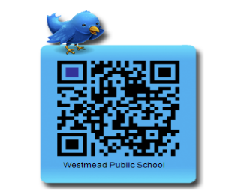
Join our Twitter account and stay up to date with school information.
Exemplary Classroom Practice
High Quality Feedback and Assessment
Student Growth and Attainment

Key Learning Area Overview
Students in Kindergarten will work towards achieving Early Stage 1 outcomes.
Class programs may differ slightly due to student needs and interests.
ENGLISH | Speaking and Listening:  Students will participate in activities to:  - use interaction skills  - listen while others speak  - follow simple instructions  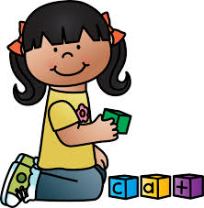  Reading and Viewing:  Students will be exposed to:  - a range of texts (printed, visual and digital text)  Students will develop skills and strategies to:  - decode letters and sounds  - read short, predictable texts on familiar topics  Writing and Representing:  Students will learn to:  - correctly form each letter using NSW foundation style handwriting  - create imaginative, informative and persuasive texts
MATHEMATICS | Students will use:  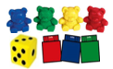  - everyday language  - concrete materials  - informal recordings  Number and Algebra  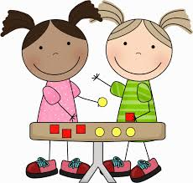  Students will learn to:  - count  - represent numbers  - model adding and subtracting  - copy and continue repeating patterns  Measurement and Geometry  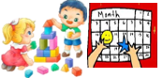  Students will learn to:  - sort and describe two-dimensional shapes and three-dimensional objects  - connect events and the days of the week  - tell the time on the hour  Statistics and Probability  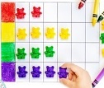  Students will learn to :  - make and interpret data displays (e.g. picture graphs).
SCIENCE & TECHNOLOGY | Students develop skills in:  - conducting scientific investigations  - designing and producing solutions  Earth and Space  Students will explore:  - changes in the weather  - changes in day and night  - how living things respond to changes in their environment  Living World  Students will explore:  - the basic needs of some plants and animals  - how living things can be used to meet our needs
HISTORY | Personal and Family Histories  Students will explore:  - stories of their own family heritage  - family events
PDHPE | With their RFF teacher, students will learn about:  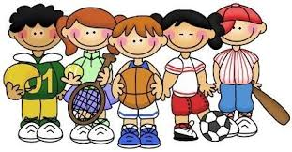  - me, myself and others  - healthy living  - fundamental movement skills  During grade sport, students will participate in activities to:  - strengthen gross motor and coordination skills
CREATIVE AND  PERFORMING  ARTS | Students will develop a range of skills in:  - Drama, Visual Arts, Music and Dance  Many of the activities are linked to concepts and content explored in other learning areas.
POSITIVE BEHAVIOUR FOR LEARNING  STRONG MINDS | Positive Behaviour for Learning  - school rules: Be safe, Be respectful, Be responsible and Be a learner  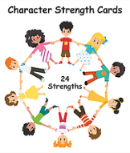  Strong Minds  - a whole school approach to support improvements in student wellbeing  - supports our whole school community in developing a culture of inclusiveness and resilience
LIBRARY | 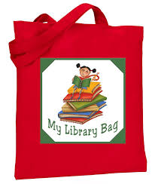  - a fortnightly lesson in the K-2 Library  - Students will bring home a note with library related information  - Students need to bring a suitable bag for borrowing with their name labelled  Lessons over the semester will focus on:  - Library rules and procedures;  - Participating in the 2022 Premier’s Reading Challenge (PRC)
HOME ACTIVITIES | To further support reading enjoyment and concepts explored in the classroom teachers will provide:  Home readers: every week  Literacy home activities: every term  Numeracy home activities: every term
WEEKLY ACTIVITIES | Scripture: Thursday  Sport Day: Thursday  Library Day: Each class is on different day. Class teacher will inform their own class.
CLASSROOM REQUIREMENTS | Please provide a Library bag for your child. You may provide a box of tissues, bottle of hand sanitiser and glue stick (Bostik brand preferred) to your child’s teacher to use in the classroom.
BIRTHDAYS | To comply with COVID-19 guidelines, we are asking that families please do NOT send cakes, sweets, gifts, etc. to share on your child’s birthday.

If you have any further queries, please make an appointment to see your child’s class teacher, Mrs Cetindag (Kindergarten Assistant Principal) or Mr Scally (K-2 Deputy Principal).

Please be assured teachers will contact you if there are any concerns or questions to support your child’s learning and wellbeing.

Mr Jenkins Mr Scally Mrs Meral Cetindag Kindergarten Teachers
Principal Deputy Principal Relieving Assistant Principal

February 2022

