Year 1 Parent Information - Semester 1 2022
Dear Parents and Carers

Welcome to Year 1, a special welcome to all the families who are new to our school. All students have started the year with great enthusiasm for learning in their new classes. Year 1 teachers and additional staff working with the grade are:

1K  1M  1S  1T  1W  1Z | Mrs Kadian  Ms Matijevic  Mrs Stevanja  Ms Tilbury and Mrs Colucci  Mrs Watts and Mrs Destefano  Ms van Zanten | EAL/D  LaST | Miss Hussein  Ms Singleton  Mrs Misson | Library  RFF | Mrs Azar  Mrs Kougellis  Mrs Ireland  Mrs Destefano
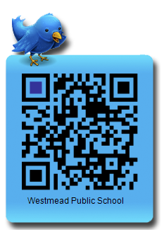
Our 2021 – 2024 School Improvement Plan focuses on the following areas:
Join our Twitter account and stay up to date with school information.
Student Growth and Attainment | High Quality Feedback and Assessment | Exemplary Classroom Practice
More information will be available for you on the school website later in the year.
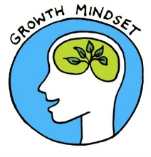
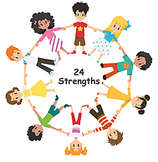
This year teachers continue to include the Strong Minds wellbeing program across all learning areas. It is a whole school approach that is fully researched and evidence based to support improvements in wellbeing. It complements our school’s existing expectations with Positive Behaviours for Learning through a shared language for staff, students and families. Strong Minds is based on Positive Psychology strategies that strengthen individual wellbeing and learning. This supports our whole school community in further developing our school culture of inclusiveness and resilience.

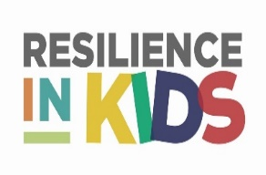

Additional information:
CLASSROOM REQUIREMENTS | We are very appreciative of your support in providing the items requested for your child’s classroom for 2021. If you are unsure of these items or need to clarify, please see the school website or the class teacher. Please note, it is your child’s responsibility to look after their own equipment, including their hats, lunch boxes and water bottles.
BIRTHDAYS | Birthdays are a special time for children. This year, due to COVID restrictions, no food, treats or gifts will be distributed to students on your child’s birthday.
NUTS | Please avoid sending food containing nut products for Recess or Lunch. This includes Peanut Butter, Nutella and nut mixes. Many students in the school have allergies to nut products.

Students in Year 1 will work towards achieving Stage 1 outcomes. Teachers meet regularly to plan similar learning experiences for students and ensure consistency across the grade. Class programs may differ slightly due to student needs, interests and abilities. The following provides an overview of learning areas for Year 1.

ENGLISH | Speaking and Listening: Students participate in activities to develop skills in clarifying and communicating their ideas, explore issues, solve problems and develop understandings in all Key Learning Areas.  Reading and Viewing: Students will develop skills and strategies to decode and understand information through modelled, guided and independent tasks. They will be exposed to a range of materials, including printed, visual and digital. Daily reading at home is important for students to consolidate skills learned at school.  Writing and Representing: Students develop handwriting, spelling, grammar and punctuation through modelled, guided and independent writing experiences. Throughout the year, students will learn to create imaginative, informative and persuasive texts.
MATHEMATICS | Students will actively participate in investigative lessons where they will build their knowledge and skills in Number & Algebra, Measurement & Geometry and Statistics & Probability. Students are explicitly taught to apply problem-solving skills by using concrete materials, collaborative communication and through drawing or writing to describe a method used to obtain an answer. Learning experiences may be whole class, small group or individual.
SCIENCE & GEOGRAPHY | In Term 1, students will develop skills and knowledge in Geography through the unit Features of Places. Students will learn to describe features of places and the connections people have with places. They will learn to communicate information and use geographical tools for inquiry.  In Term 2, students will develop skills and knowledge in Science through the unit Living World. Students will learn to describe observable features of living things and their environments. Students will investigate how plants and animals are used for food and fibre products.
PDHPE | Once a week, students will be learning about healthy living and fundamental movement skills with their RFF teacher. On Wednesday, Year 1 will have grade sport. Students can wear their sports uniform and sports shoes. They will participate in activities to strengthen gross motor and co-ordination skills. Sport activities are designed to support students in developing and maintaining resilience, a growth mindset, core values and positive relationships.
CAPA | Through integrated learning tasks as well as explicit teaching, students will develop a range of skills in Visual Arts, Drama, Dance and Music. Many of the activities are linked to concepts and content explored in other learning areas.
LIBRARY | All Year 1 classes will have a fortnightly lesson in the K-2 Library. This will include time for borrowing and returning books. Your child will bring home a note with the day and week they visit the library, as well as other library related information. Please ensure students have a suitable bag for borrowing (preferably a waterproof bag) with their name clearly labelled.  Lessons over the term will focus on:  - Library rules and procedures;  - Cybersafety and Digital Citizenship introduction, including responsible internet usage.
HOMEWORK | Homework is given on Monday and collected on Friday. Homework provides a range of learning opportunities. Some tasks may include online programs which reinforce academic work based on classroom learning, other activities included encourage students to be more active and participate in household tasks. Homework is created for students to complete with minimal supervision and help. Daily reading with an adult is strongly encouraged.

Due to COVID restrictions, this year’s Meet the Teacher will be online. There will be a short video from your child’s class teacher and a zoom session with grade information. Both will be available later in Term 1.

If you have any further queries, please make an appointment to see your child’s teacher, Ms Tilbury (Assistant Principal Year 1) or Mr Scally (K-2 Deputy Principal). Please be reassured teachers will contact you if there are any concerns or questions to support your child’s learning and wellbeing.
For this reason and in case of an emergency, we ask that you ensure your contact information is up to date at the office.
Working in Co-operation,
Mr Jenkins Mr Scally Ms Tilbury Year 1 Teachers
Principal Deputy Principal Relieving Assistant Principal

February 2022

